REDYNOX
CYBER SECURITY INTERNSHIP
Task 1 Report
Introduction to Network Security Basics
Intern | Azorji perpetual Mmesomachi
Organisation | Redynox
Task | Task 1 - Introduction to Network Security Basics
Report Date | 8 October 2026

Practical focus: host firewall verification, wireless security verification, and Wireshark traffic analysis

1. Introduction
This report documents the completion of Task 1 of the Redynox Cyber Security Internship. The task focused on understanding foundational network security concepts, applying basic security controls on a Windows workstation and wireless network, and using Wireshark to observe and interpret real network traffic.
The practical activity was carried out in a small-network environment using a Windows computer connected over Wi-Fi. The work combined configuration verification with packet-level analysis. The objective was not to conduct a full penetration test, but to demonstrate basic defensive security awareness and the ability to interpret network behaviour.

2. Objectives
- Identify common network threats, including viruses, worms, trojans and phishing attacks.
- Understand the role of firewalls, encryption, secure wireless configuration and strong authentication.
- Verify basic security settings on the workstation and wireless connection.
- Capture and analyse network traffic with Wireshark, with attention to DNS, TLS/HTTPS and TCP behaviour.
- Document observed events accurately without treating normal network anomalies as confirmed attacks.

3. Network Threats Researched
Network security threats can affect confidentiality, integrity, availability and the ability of users to trust digital services. The following threats were reviewed as part of the task.
Threat | Description | Potential Impact | Basic Prevention
Virus | Malicious code that infects files or system areas and can replicate when the host is executed or accessed. | File corruption, loss of data, degraded performance or further compromise. | Anti-malware protection, software updates, safe downloads and backups.
Worm | Self-replicating malware that can spread through networking mechanisms without needing the same user interaction as many file-infecting viruses. | Rapid spread across vulnerable systems, resource consumption and service disruption. | Patching, network segmentation, least privilege, endpoint protection and monitoring.
Trojan | Malware disguised as a legitimate or useful program or file to persuade a user to execute or install it. | Unauthorized access, credential theft, data loss or installation of additional malware. | Verify software sources, avoid suspicious attachments, use endpoint protection and least privilege.
Phishing | Social engineering in which an attacker poses as a trusted person or organisation to obtain information, access or a user action. | Credential theft, malware infection, fraud, data breach or account compromise. | User awareness, MFA, careful link/attachment handling, email filtering and reporting.
CISA describes phishing as a form of social engineering in which a threat actor impersonates a trustworthy colleague, acquaintance or organisation to obtain sensitive information or network access. CISA also describes viruses, worms and trojans as forms of malware with different propagation or delivery characteristics. [1][2]

4. Basic Network Security Concepts
Firewall: A firewall controls the flow of network traffic between hosts or networks with different security postures. In a host-based context, it can allow or restrict connections according to rules and helps reduce unauthorized access. [3][4]
Encryption: Encryption transforms plaintext into ciphertext so that the original meaning is concealed from unauthorized readers. It helps protect information while it is stored or transmitted. [5]
Secure wireless configuration: Wireless security should use a strong authentication/encryption mode such as WPA2 or WPA3 and a hard-to-guess Wi-Fi password. NIST specifically recommends WPA2/WPA3 for home wireless protection. [6]
Security updates and endpoint protection: Operating-system and application updates reduce exposure to known vulnerabilities, while endpoint security controls can help detect and block malware. [6]
Least privilege and strong authentication: Users and applications should receive only the access they need, while strong passwords and multi-factor authentication can reduce the impact of compromised credentials. [2][6]

5. Practical Environment
The practical work used a Windows workstation connected to a wireless network. Wireshark was used for packet capture and protocol analysis. The workstation local address observed in the capture was 192.168.18.8, while 192.168.18.1 responded to DNS queries as the local DNS resolver. The exact identity of remote services was not assumed from IP addresses alone; the analysis relied on protocol fields and hostnames visible in the capture.

6. Basic Security Measures Implemented / Verified

6.1 Windows Defender Firewall
Windows Defender Firewall was checked and confirmed to be enabled for both Private and Public network profiles. The setting to notify the user when Windows Defender Firewall blocks a new application was also enabled for both profiles. This provides a basic host-level control for filtering network traffic and reducing unauthorized access. Microsoft states that Windows Firewall filters traffic and can allow or restrict connections using criteria such as IP addresses, ports and application paths. [4]
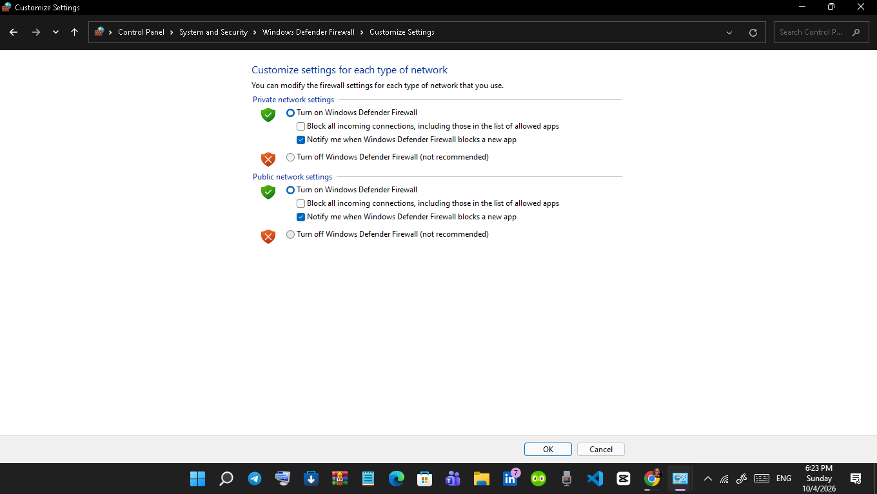
Figure 1: Windows Defender Firewall enabled for Private and Public network profiles.

6.2 Wireless Security
The active Wi-Fi connection was checked from Windows Command Prompt using the netsh wlan show interfaces command. The workstation reported WPA2-Personal authentication and CCMP cipher usage over a 5 GHz connection. This satisfies the task requirement to verify that the wireless network uses WPA2 or WPA3. NIST recommends WPA2/WPA3 as a stronger baseline for home wireless protection. [6]
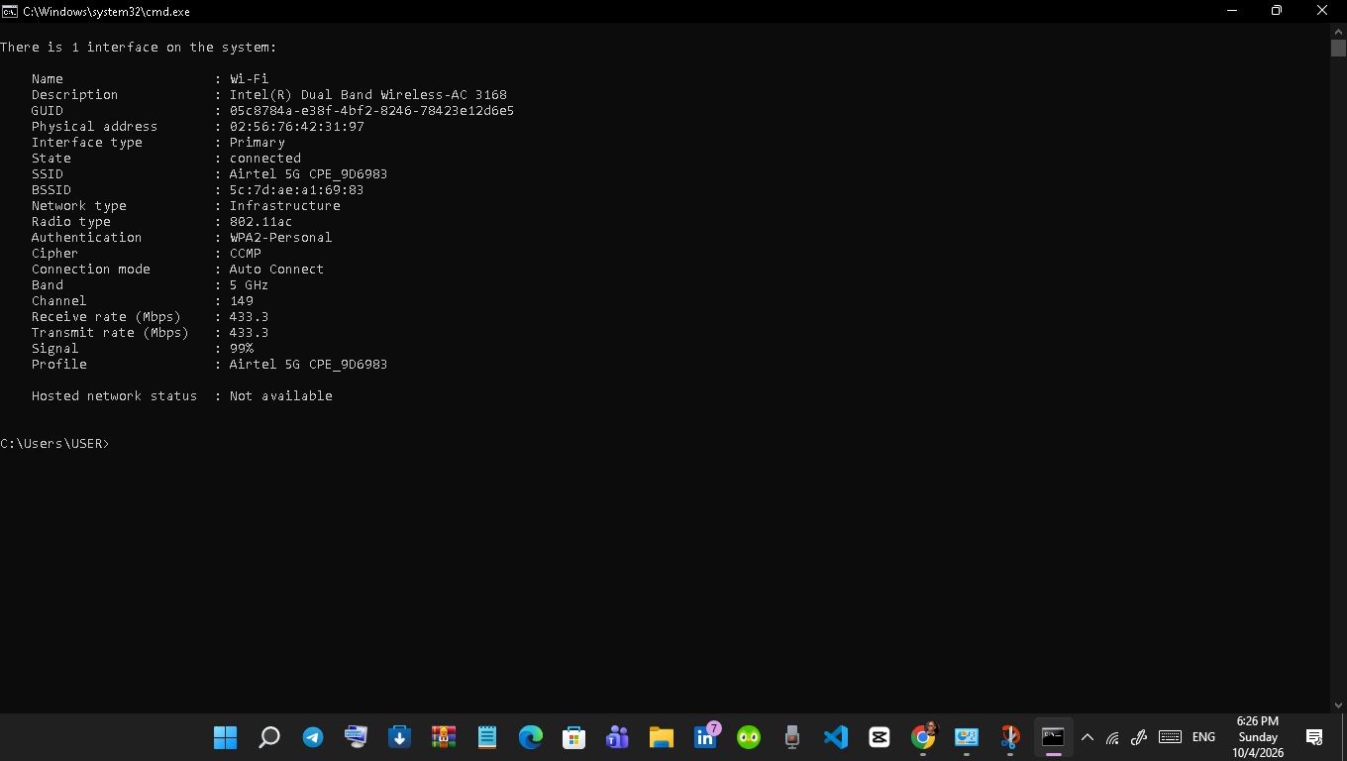
Figure 2: Windows WLAN interface output showing WPA2-Personal authentication and CCMP encryption.

6.3 Credential Configuration Note
Important scope note
The screenshots collected for this task verify firewall and Wi-Fi encryption settings, but they do not prove that the router or access-point default administrator password was changed. This item is therefore recorded as a recommended follow-up control rather than as completed work. It should only be marked complete after the router credentials have actually been changed and verified.
The collected evidence confirms the firewall and wireless encryption settings, but it does not show a router administrator password change. For accuracy, this report does not claim that the default router credentials were changed. A password change should be completed and documented as an additional hardening step if it has not already been done.

7. Wireshark Traffic Capture and Analysis
Wireshark was used to capture traffic generated during ordinary internet activity. The capture contained DNS, TCP, TLS 1.2, TLS 1.3 and QUIC traffic. Wireshark provides analysis flags for retransmission and related TCP conditions, which were used during the investigation. [7]
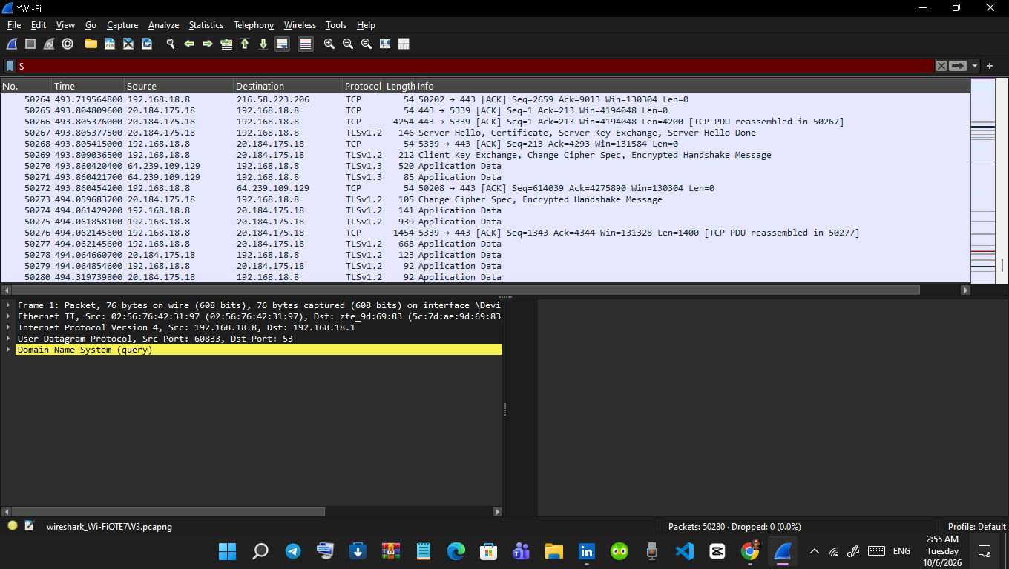
Figure 3: Wireshark capture showing DNS, TCP and TLS traffic during normal network activity.

7.1 DNS Analysis
DNS filtering showed the local workstation (192.168.18.8) sending queries to 192.168.18.1. Observed queries included in.grammarly.com, gnar.grammarly.com, capi.grammarly.com, applet-bundles.grammarly.net and play.google.com. The responses returned IPv4 addresses for requested A records. This demonstrates the normal DNS process in which a client requests name resolution and receives address information that can be used for subsequent network communication. Wireshark documentation notes that DNS is commonly used to resolve hostnames to IP addresses for applications such as web browsers. [7]
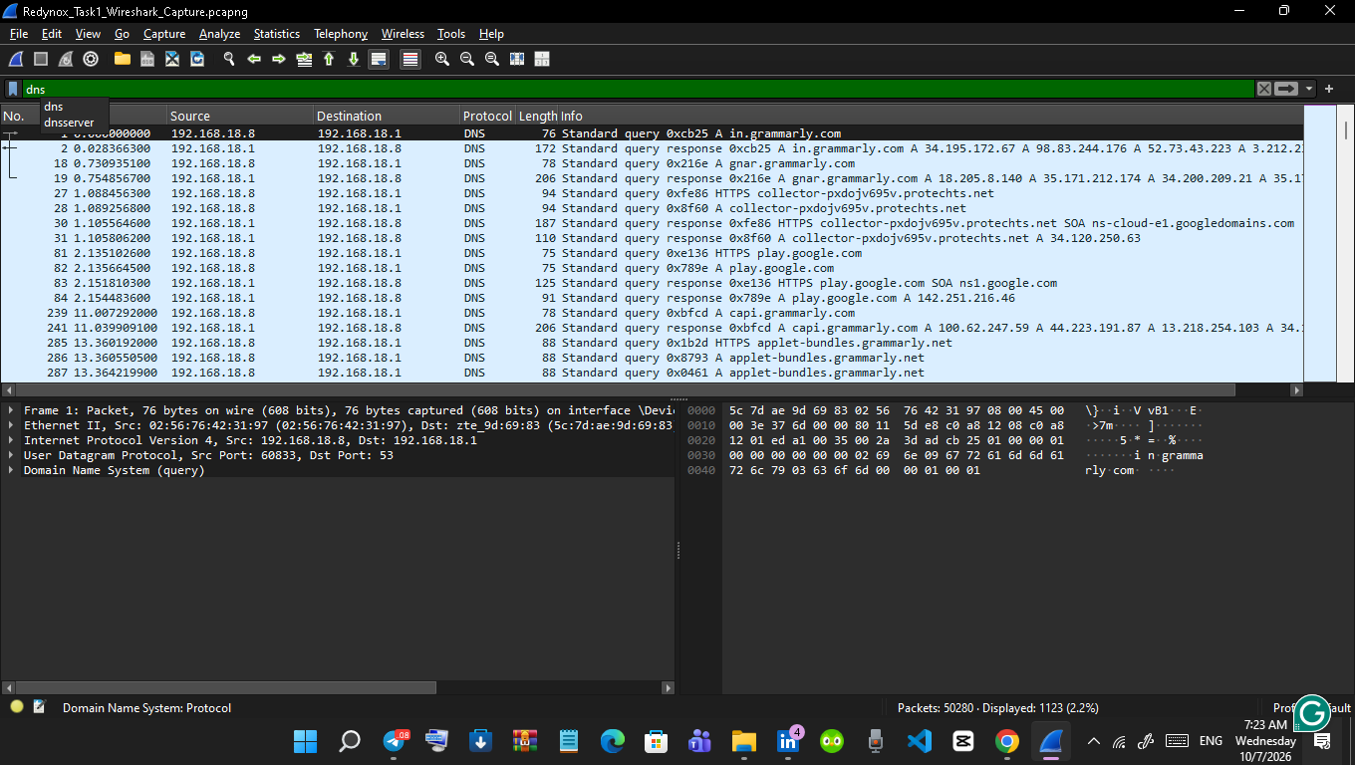
Figure 4: Wireshark DNS-filtered traffic showing DNS queries and responses.
Representative DNS observation
Example: 192.168.18.8 queried 192.168.18.1 for an A record for in.grammarly.com, and the resolver returned multiple IPv4 addresses. The presence of several addresses is not, by itself, evidence of malicious behaviour.

7.2 TLS / HTTPS Analysis
TLS filtering showed a typical TLS 1.2 handshake between 192.168.18.8 and 34.195.172.67 for the SNI in.grammarly.com. The sequence included Client Hello, Server Hello, Certificate, Server Key Exchange/Server Hello Done, Client Key Exchange/Change Cipher Spec/Encrypted Handshake Message, and subsequent Application Data. Another Client Hello was observed for gnar.grammarly.com. TLS 1.3 Application Data and QUIC handshake traffic were also present.
The observed Application Data records indicate protected TLS application traffic. The capture itself did not provide the plaintext contents of these encrypted records. The analysis therefore focused on endpoints, protocol versions, handshake sequence and packet behaviour rather than attempting to infer encrypted content.
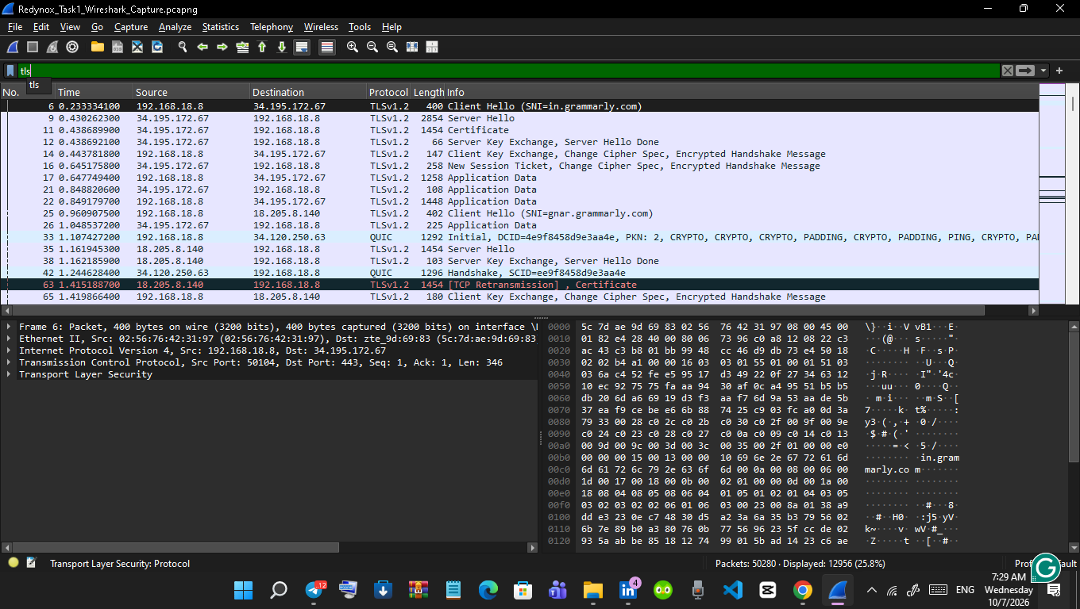
Figure 5: Wireshark TLS-filtered traffic showing TLS handshakes and encrypted Application Data.

7.3 Retransmission Analysis
Several TCP retransmissions were observed, including TLS Application Data retransmissions and a TCP Fast Retransmission involving 52.123.129.14. Wireshark also displayed Selective Acknowledgement (SACK) information and TCP PDU reassembly. These observations are consistent with TCP loss recovery or delivery issues. Wireshark documents retransmission analysis flags as indicators of packet sequence conditions associated with retransmission, not as automatic indicators of an attack. [7]
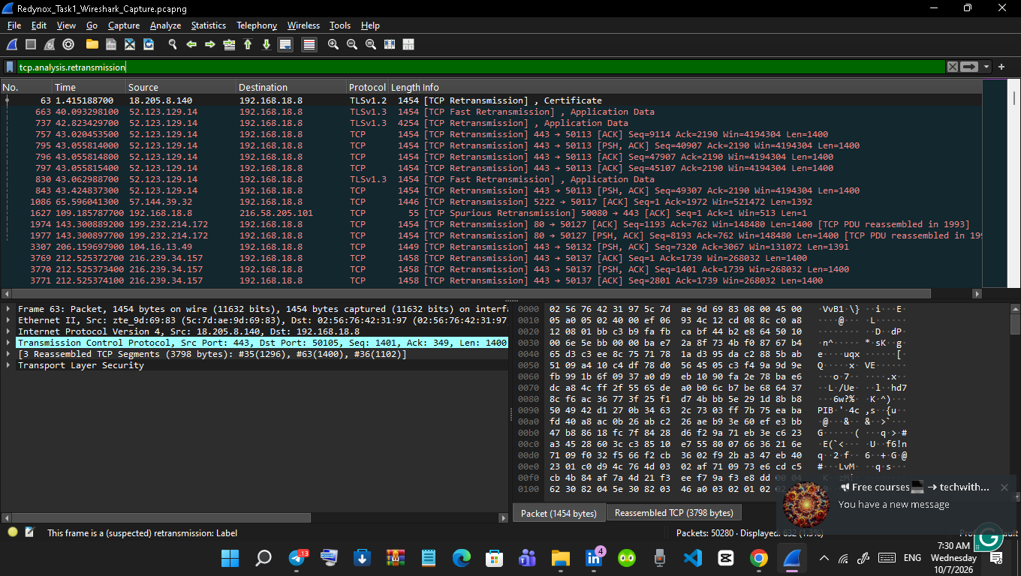
Figure 6: Wireshark retransmission filter showing repeated TCP/TLS retransmissions.
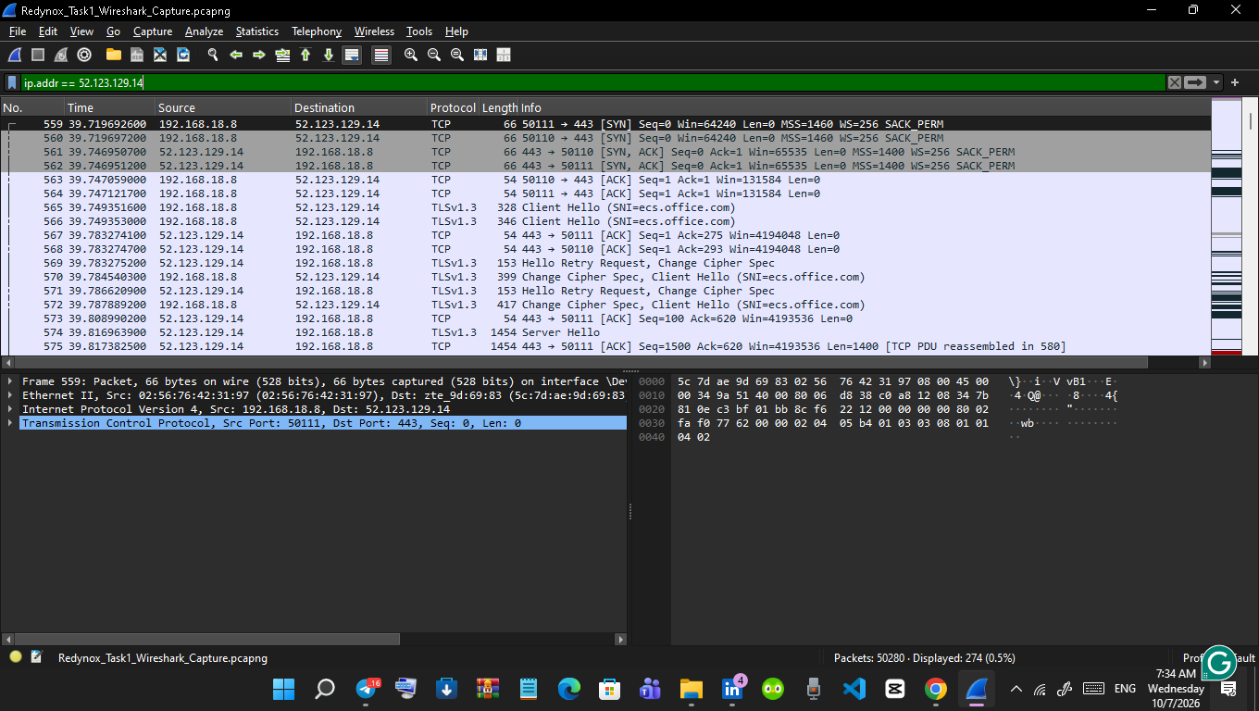
Figure 7: Wireshark traffic filtered for remote host 52.123.129.14, showing TCP 443 and TLS 1.3 communication.

7.4 TCP Reset Analysis
A filter for TCP reset flags identified several RST and RST, ACK packets. Observed examples included a reset from 142.251.152.119 to 192.168.18.8 and resets from 192.168.18.8 toward 52.123.129.14 and 4.150.223.110. TCP reset packets are used to abruptly terminate or reject connections and can occur for legitimate reasons. The presence of these packets was therefore treated as an event requiring contextual analysis rather than as proof of compromise.
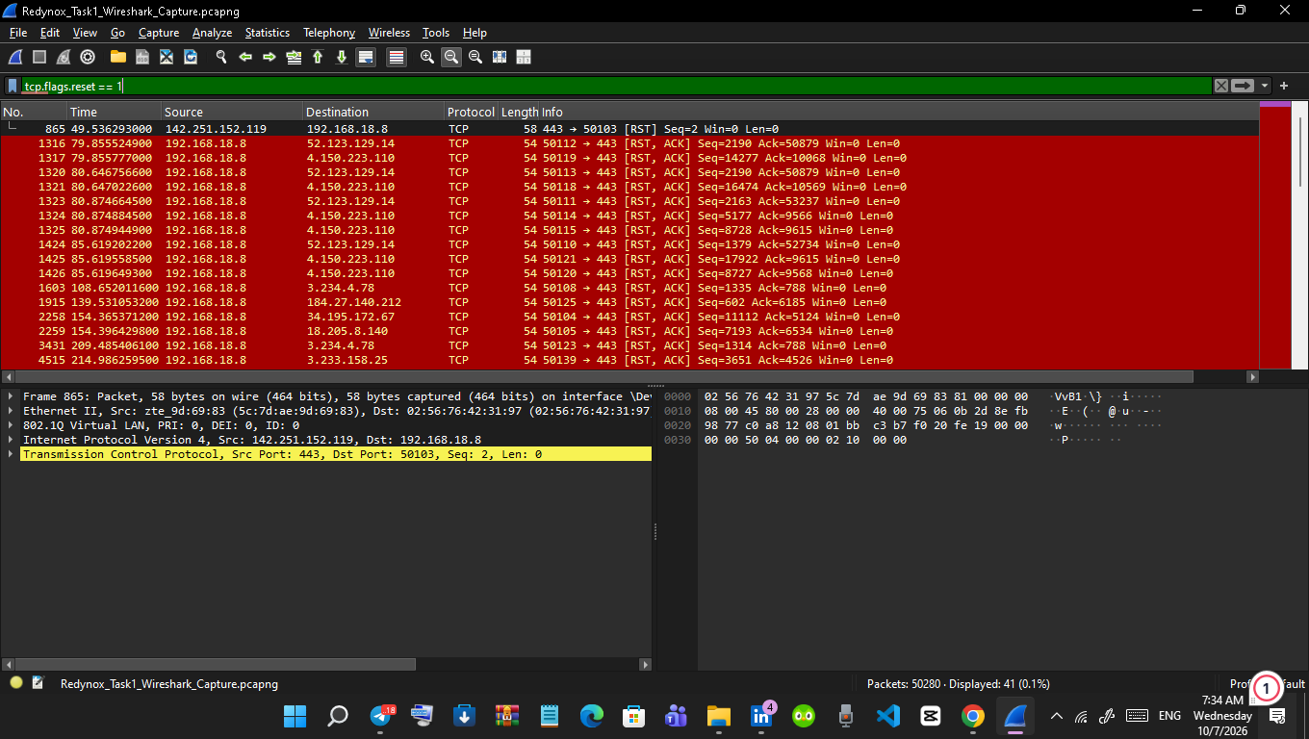
Figure 8: Wireshark TCP reset filter showing RST and RST, ACK packets.

7.5 Suspicious-Traffic Assessment
One observed hostname, collector-pxdojv695v.protechts.net, produced DNS activity in the capture. Its presence alone was not treated as malicious because DNS visibility by itself does not establish the reputation, ownership or purpose of a destination. A stronger investigation would correlate the hostname with the process that generated the connection, inspect the TLS certificate, review endpoint logs and application context, and use trusted threat-intelligence sources where appropriate.
Overall assessment
The analysed traffic was largely consistent with ordinary application and web communications. Retransmissions and TCP resets were present, but the available evidence was insufficient to conclude that the workstation was under attack. This distinction is important: unusual network events should be investigated in context rather than automatically classified as malicious.

8. Security Measures and Why They Help
Control | Observed/Status | Security Benefit
Windows Defender Firewall | Verified enabled on Private and Public profiles. | Filters network traffic and reduces exposure to unauthorized connections.
Firewall block notifications | Verified enabled. | Provides user awareness when an application is blocked by firewall policy.
WPA2-Personal + CCMP | Verified on active Wi-Fi connection. | Provides wireless authentication and encryption for the local WLAN.
TLS 1.2 / TLS 1.3 observed | Verified through Wireshark capture. | Protects application data in transit for TLS-secured communications.
Default router password change | Not verified in evidence collected. | Should reduce the risk of unauthorized administrative access to the network device.
Wireshark monitoring | Completed. | Provides visibility into protocols, endpoints and network anomalies for investigation.

9. Additional Measures for a Larger Network
- Network segmentation or VLANs to limit lateral movement and isolate sensitive systems.
- Intrusion Detection and Prevention Systems (IDS/IPS) for centralised detection of suspicious patterns.
- Centralised logging and Security Information and Event Management (SIEM) to correlate events across hosts and network devices.
- Multi-factor authentication and role-based access control for critical systems.
- Regular vulnerability assessment, patch management and secure configuration reviews.
- Endpoint detection and response (EDR), malware protection and application control.
- Secure backups, incident-response procedures and recovery testing.
- Security awareness training and phishing simulations for users.

10. Reflection on Security Best Practices
If educating everyday users about network security, I would focus on a few simple habits that have high practical value: use strong and unique passwords, enable multi-factor authentication where available, keep operating systems and applications updated, use trusted Wi-Fi security settings, and treat unexpected links, attachments and requests for sensitive information with caution. Users should also know how to report suspicious messages instead of interacting with them. These practices complement technical controls because many attacks begin with human interaction. CISA and NIST both emphasise user awareness, secure authentication, safe handling of links and attachments, updates and secure wireless configuration. [2][6]

11. Limitations of the Exercise
- The assessment represents a short, single-user capture session on a small network; it is not a full vulnerability assessment or penetration test.
- The Wireshark capture shows network-level evidence but does not by itself identify the exact local application responsible for every connection.
- IP addresses and hostnames should not be treated as proof of maliciousness without supporting evidence.
- The router administrator password was not evidenced as changed in the screenshots collected for this task.

12. Conclusion
The practical exercise provided hands-on exposure to foundational network security controls and packet-level analysis. Windows Defender Firewall was verified as enabled on Private and Public networks, and the active Wi-Fi connection was verified to use WPA2-Personal with CCMP encryption. Wireshark analysis demonstrated DNS resolution, TLS 1.2/TLS 1.3 encrypted communication, QUIC traffic, TCP retransmissions and TCP reset events. The investigation also reinforced an important analytical principle: security analysts should distinguish genuine indicators of compromise from normal protocol behaviour and network-performance events.
Overall, the task improved practical understanding of how a host is protected, how wireless security is configured, and how network traffic can be observed and interpreted during routine system use. The filtered Wireshark evidence also reinforced the importance of contextual analysis: retransmissions and TCP resets can be legitimate network events and should not be labelled as attacks without corroborating evidence.

13. References
[1] CISA, Malware Tip Card. https://www.cisa.gov/sites/default/files/publications/Malware_1.pdf
[2] CISA, Phishing: Social Engineering / Phishing Guidance. https://www.cisa.gov/sites/default/files/publications/phishing-infographic-508c.pdf
[3] NIST CSRC, Firewall Glossary / SP 800-41 Rev. 1. https://csrc.nist.gov/glossary/term/firewall
[4] Microsoft Support, Firewall and network protection in the Windows Security app. https://support.microsoft.com/en-us/windows/security/windows-security/firewall-and-network-protection-in-the-windows-security-app
[5] NIST CSRC, Encryption Glossary. https://csrc.nist.gov/glossary/term/encryption
[6] NIST, Cybersecurity Awareness Month: Securing Devices at Home and Work. https://www.nist.gov/blogs/cybersecurity-insights/cybersecurity-awareness-month-securing-devices-home-and-work
[7] Wireshark, User Guide. https://www.wireshark.org/docs/wsug_html/

Appendix A - Evidence Summary
Evidence | Key observation | Use in report
Figure 1 - Firewall.png | Windows Defender Firewall enabled for Private and Public networks; block notifications enabled. | Supports firewall configuration section.
Figure 2 - cmd.png | Active WLAN shows WPA2-Personal authentication and CCMP cipher. | Supports wireless security verification.
Figure 3 - capturing.png | Live capture contains DNS, TCP, TLS 1.2 and TLS 1.3 traffic. | Supports initial Wireshark traffic analysis.
DNS filter output | Queries/responses for Grammarly-related domains, Google Play and a telemetry-looking hostname. | Supports DNS analysis.
TLS filter output | TLS handshakes, certificates, encrypted Application Data and QUIC handshake observed. | Supports TLS/HTTPS analysis.
Retransmission filter output | Multiple retransmissions involving 52.123.129.14. | Supports anomaly/network-performance analysis.
RST filter output | Several TCP RST and RST, ACK packets. | Supports TCP reset analysis.
Figure 4 - DNS.png | DNS filter output | Queries/responses for Grammarly-related domains, Google Play and a telemetry-looking hostname.
Figure 5 - tls.png | TLS filter output | TLS 1.2/1.3 handshakes, certificates, encrypted Application Data and QUIC handshake observed.
Figure 6 - tcp analysis.png | Retransmission filter output | Multiple retransmissions, including TLS Application Data retransmissions and events involving 52.123.129.14.
Figure 7 - Ip addr.png | Remote-host filter output | TCP 443 connection with TLS 1.3 Client Hello (SNI=ecs.office.com) and related handshake traffic for 52.123.129.14.
Figure 8 - tcp flages.png | RST filter output | Several TCP RST and RST, ACK packets observed in the capture.
Prepared from the practical evidence collected during the Redynox Task 1 exercise. The report intentionally distinguishes verified observations from recommendations and avoids asserting malicious activity without sufficient evidence.

